P4: Part A

# Deployed project link: <https://skillender.herokuapp.com/projects/>

# Insomnia Screenshots

## Auth token

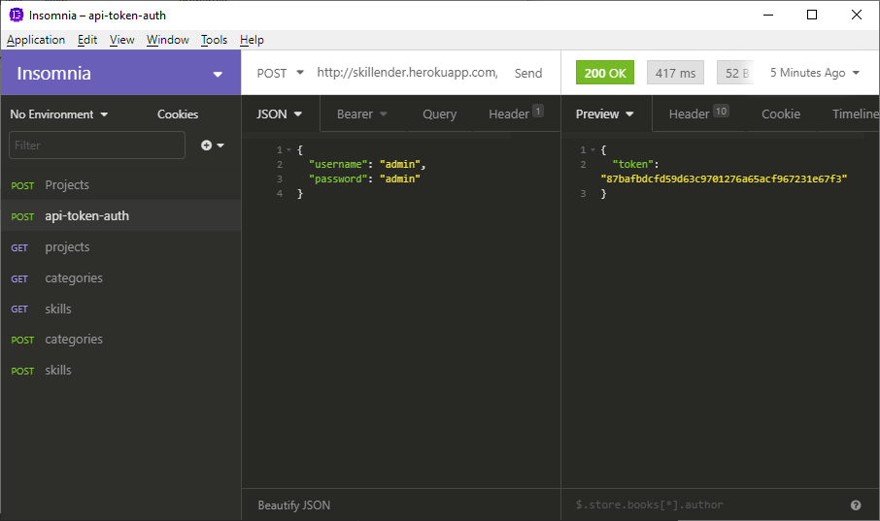

## GET method

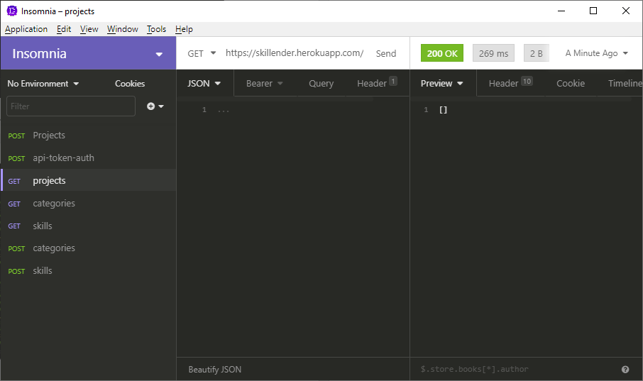

## POST

